الجمهورية اللبنانية
الاسم والشهرة:--------------------

رقم المرشح :----------------------
وزارة التربية والتعليم العالي الامتحانات الرسمية لشهادة الامتياز الفني
المديرية العامة للتعليم المهني والتقني لدورة عام 2017 الثانية
===============
الاختصاص والرمز : المعلوماتية الادارية ( 23104)
المادة : برمجة ويب Web المعدل: (10)
المستندات المسموح بها : لا شيء المدة : ساعتان

- Write the appropriate HTML5 and JAVASCRIPT tags to obtain as result the following page, that calculate the weekly salary, while respecting the following conditions: (4 pts)
- "number of hours": is a textbox that cannot contain empty values. The test should be done according to a function when we click outside the field.
- After a click on the button "Calculate" the weekly salary will be calculated and displayed in the textbox "sal" as follow:
  - If the number of hours is less than or equal to 40 then the salary is equal to: number of hours * hourly rate.
  - Otherwise the salary is equal to: number of hours * hourly rate *2.
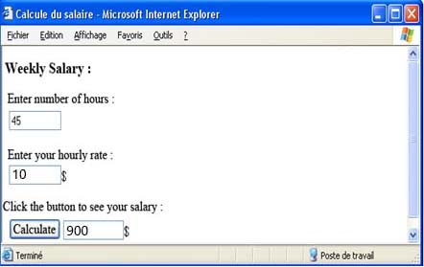

- Write the appropriate HTML5 tags and the appropriate CSS properties to obtain as result the following page: (5 pts)
- The font size in this page is 20 pixels.
- The « header » and « footer » parts have the following characteristics :
header | footer
- Background color: black.  - Font color: white.  - Text alignment: center, 26 pixels.  - Width: 700 pixels.  - Height: 80 pixels.  - Border thickness: 2 pixels  - Border type: « dashed » | - Background color: black.  - Font color: White.  - Text alignment: center, 16 pixels.  - Width: 700 pixels.  - Height: 30 pixels.  - Round Border: 10 pixels.
- The "Top of Page" is a link towards the top of the page.
- The bullets and the numbers are lists.
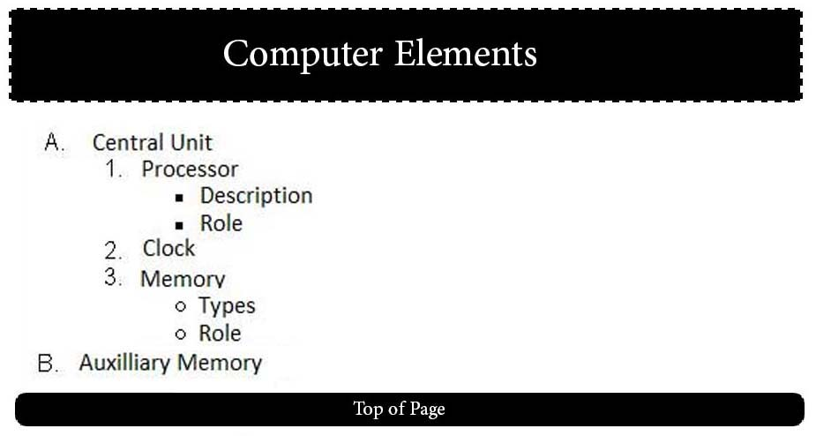

- Write the appropriate HTML tags to create the following page, by using the appropriate CSS properties for the page formatting and layout by using absolute positioning as follow: (3 pts)
- This page contains 2 paragraphs.
- Each paragraph has the following characteristics:
- Width: 200 pixels; Height: 50 pixels.
- Border type: solid; Border thickness: 2 pixels.
- The paragraph 1 has the following characteristics:
- Position: absolute, 100 pixels from the top of the page and 20 pixels from the left of the page.
- The paragraph 2 has the following characteristics:
- Position: absolute, 100 pixels from the top of the page and 400 pixels from the left of the page.

الاختصاص والرمز : المعلوماتية الادارية ( 23104) المادة : برمجة ويب Web

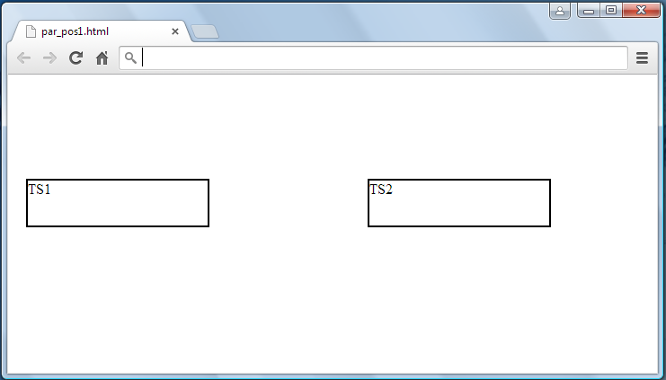
100 px
180 px
20 px
400 px

- Write the appropriate HTML5 tags to obtain the following page : (4 pts)

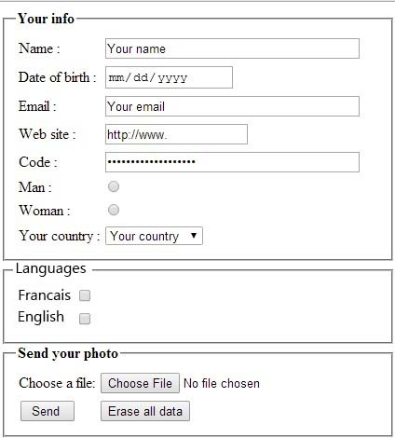 | - Name: Input field, 40 visible characters, and maximum 256 characters.  - Indicate the appropriate type for each of the following fields: Date of birth, Email, Web site, Code.  - Man / Woman: Radio button which only one choice is acceptable.  - Your country: A list box that contains the following values : "France, Canada, Lebanon, Others"  - Francais / English: Checkbox, many choices are acceptable.  - Choose a file: Input field of type file.  - A button Send to send data towards: "www.mysite.com/select.php" using the post method.  - A button Erase all data to reset all values.

- Write the appropriate HTML5 tags and the appropriate CSS properties to obtain as result the following page: (4 pts)

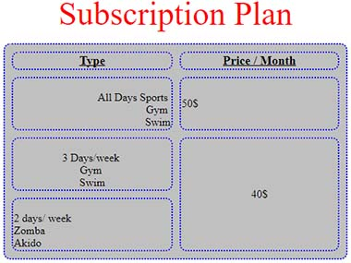 | - The table title is: "Subscription plan", the title size is: 20 pixels aligned at the top center of the table.  - The table has the following characteristics:  Width: 500 pixels; Height: 50 pixels; Space between borders: 10 pixels; Round borders: 10 pixels; background: grey.  - The table and cells border thickness is 2 pixels; the color of the border is blue. (Use rgb, rgba or hexadecimal code)  - Keep the table format.

